

**Department of Electronics and Communication Engineering**

***Gauhati University Institute of Science & Technology***

**Gauhati University, GNB Nagar, Ghy-14**

**---- MINI PROJECT REPORT ----**

**PROJECT TITLE: DIGITAL CLOCK USING 7 SEMENT DISPLAY**

**SUBMITTED BY:**

**Roll no: 200101030 Name: DHRUBA JYOTI DAS**

1. **INTRODUCTION**

The digital watch is a fundamental yet essential device used for accurate time measurement in various applications. Our project focuses on designing and implementing a digital stopwatch using 7-segment displays, a 7490 decade counter, and a 7447 BCD-to-7-segment decoder.

The primary objective of this project is to create a reliable and precise stopwatch that can accurately measure minutes and seconds independently. To achieve this, we utilize the 7490 decade counter as the primary counting component, incrementing its count by one each second. The binary output of the 7490 counter is then decoded by the 7447 BCD-to-7-segment decoder, which drives the appropriate segments of the 7-segment display to visually represent the minutes and seconds.

To ensure accurate timing intervals, we have incorporated pulse generator circuits based on the 555 timer in astable mode. These circuits generate regular pulses, with one circuit providing pulse every millisecond and the other circuit providing pulse every second. These pulses trigger the counting process.

An additional unique feature of our stopwatch is the inclusion of potentiometers in the pulse generator circuit. By adjusting the potentiometer's value, the pulse frequency can be manually calibrated, allowing for customization and versatility in time measurement. This calibration feature provides the ability to convert minutes into seconds and vice versa, catering to specific timing requirements.

The stopwatch also includes a reset button that allows the timing to be reset, initiating a new counting cycle.

* 1. **Importance:**

The development of the digital stopwatch project holds significant importance in various aspects. Here are the key areas where its significance becomes evident:

* Accurate Time Measurement: The digital stopwatch project serves as a reliable and precise time measurement tool. Its implementation using 7-segment displays, a 7490 decade counter, and a 7447 BCD-to-7-segment decoder ensures accurate representation and tracking of minutes and seconds.
* Time Management and Productivity: The digital stopwatch project promotes effective time management and productivity by providing users with a reliable tool for tracking and measuring time intervals. Whether it is for personal time management or professional tasks, the stopwatch assists in optimizing productivity, meeting deadlines, and maintaining a disciplined approach to time-based activities.
* Energy Efficiency: Implementing power-saving techniques, such as low-power modes and energy-efficient components, can optimize the battery life of the stopwatch. This would ensure prolonged usage without frequent battery replacements, making the stopwatch more reliable and cost-effective.
* Cost Effective: All the components used in the project are available at very low cost.
  1. **Applications:**

The digital stopwatch can find applications in various fields. Here are some potential uses and applications for the digital stopwatch:

* Sports Events: The stopwatch can be used in sports events, such as track and field competitions, swimming races, or cycling events, to accurately measure and record athletes' timings. It allows coaches, athletes, and officials to monitor performance, track progress, and determine winners with precision.
* Scientific Experiments: The stopwatch can be utilized in scientific experiments that require accurate timing intervals. Whether it is measuring reaction times, recording data during laboratory experiments, or conducting time-based observations, the stopwatch ensures precise and consistent timing measurements.
* Industrial Processes: The digital stopwatch can be employed in industrial settings for tasks that require precise timing. It aids in maintaining efficiency, coordinating tasks, and optimizing workflow.
* Fitness and Training: Individuals involved in fitness activities, such as running, interval training, or circuit workouts, can utilize the stopwatch to time their exercises, monitor rest periods, and track progress. It helps in structuring workouts, setting goals, and measuring performance.
* Music and Performing Arts: Musicians, dancers, and performers can utilize the stopwatch for timing rehearsals, practicing specific sections, or coordinating performances with precision. It aids in maintaining rhythm, tempo, and synchronization among multiple performers.
* Speech and Debate Events: The stopwatch can be employed in speech and debate competitions to time participants' speeches, track speaking durations, and enforce time limits. It helps in ensuring fairness, maintaining the flow of the event, and providing objective timing measurements.
* Personal Time Management: Individuals can use the stopwatch for personal time management, including timing tasks, setting reminders, or tracking study or work durations. It assists in maintaining focus, managing productivity, and improving time allocation.
  1. **Unique Features:**
* Pulse Calibration Feature: One notable aspect of our project is the inclusion of potentiometers in the pulse generator circuit. This feature allows users to manually calibrate the pulse frequency, enabling calibration of the minutes and seconds. In case of analog watches, it uses the principle of vibrations of quartz crystal. The quartz vibrate at precisely 32768 times a second. The circuit counts to oscillations and turns each 32768 vibrations into one electric pulse. But eventually they lose time due to various reasons. Same is true for mechanical watches. Therefore it is necessary to have an option for calibration. Additionally our watch has the feature for conversion of minutes to seconds, seconds to minutes and vice versa. This customization option adds versatility and adaptability to suit a wide range of timing requirements.
* Independent Minutes and Seconds Counting: Another unique aspect of our project is the independent counting of minutes and seconds. By utilizing separate counters for minutes and seconds, users can track time accurately without interference or synchronization issues. This independent counting feature enhances the precision and reliability of the stopwatch.
* Implementation of 7490 Decade Counter and utilization of 7447 BCD-to-7-Segment Decoder:: The inclusion of the 7490 decade counter as the primary counting component sets our project apart. The integration of this specific counter adds robustness and reliability to the timing functionality. The 7447 BCD-to-7-segment decoder plays a crucial role in our project by decoding the binary output of the 7490 counter and driving the appropriate segments of the 7-segment display. This integration ensures a seamless and accurate display of minutes and seconds, enhancing the overall functionality and user experience.

1. **BLOCK DIAGRAM:**

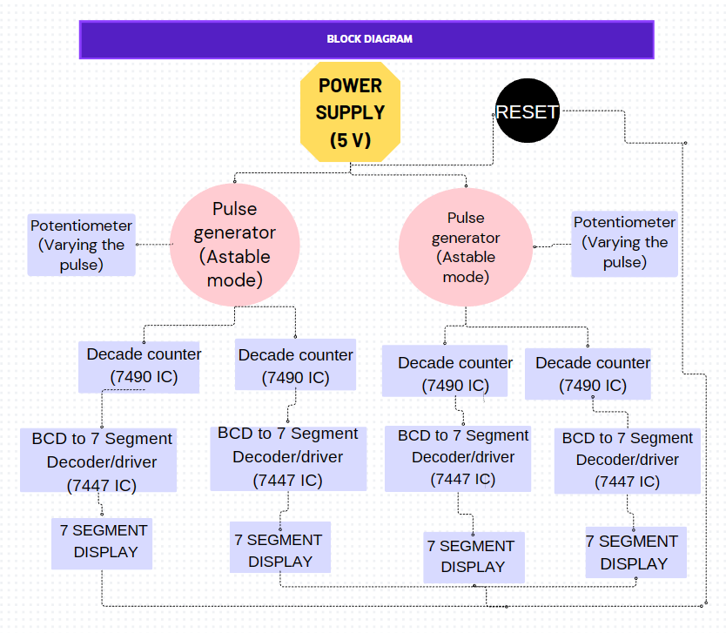

Block Diagram Explanation:

1. Power Supply block:

A constant 5 volts input is supplied to the entire circuit provides power to all the components.

1. Pulse generator Circuit blocks:

Two pulse generator circuits are used. These block consist two separate 555 timers in astable mode. These circuits generate regular pulses, with one circuit providing pulse every millisecond and the other circuit providing pulse every second. These pulses trigger their respective decade counters.

1. Potentiometer blocks:

Two potentiometers are connecter to the pulse generator circuits (one each). This allows the users to manually calibrate the pulse frequency, enabling calibration of the minutes and seconds.

1. Decade counter blocks:

Each of the pulse generator circuits is connected with a decade counter. A decade counter is a binary counter designed to count to 1001 (decimal 9). Here we use 7490 decade counters. A total of 4 decade counters (2 decade counters connected to one pulse generator). Normally a two cascaded decade counters would count up to 99 but we design a mod 60 counter that counts from 0 to 59 and then resets to 0 when the count of second 7490 reaches 6. Similar procedure is followed by the other two decade counters.

1. BCD to 7 Segment decoder block:

The 7490s are connected to their respective 7447 decoder ICs. The 7447s are connected to the respective 7 segment displays. The 7447 converts the binary output that is received from the counter ICs into a format that is suitable for the 7 segment displays.

1. Output block: The output block consists of the four 7 segment displays. The outputs of the 7447 ICs are connected to the corresponding segments of the respective displays, enabling the display of digits. These cascaded displays shows the milliseconds and seconds.
2. Reset Button: The reset button is connected to the power supply so whenever the button is pressed, it cuts off the power supply for a fraction of time and the counting stops and start again.

|  |  |  |
| --- | --- | --- |
| DISTRIBUTION OF THE PROJECT WORK | | |
| Roll no. | **Name** | **Contribution** |
| 200101030 | DHRUBA JYOTI DAS | Designing and building of the two mod 60 counter circuits |
| 200101040 | ANUBHAV DEY | Designing and building of the two pulse generator circuits. |

1. **Design Procedure:**
   1. 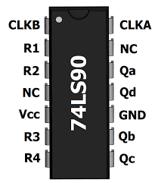**Components Used:**

* 74SL90N IC:

**74LS90**is basically a MOD-10 decade counter that generate a BCD output code. It consists of four master-slave JK flip-flop, which are internally connected to provide MOD-2 (count to 2) counter and MOD-5 counter. 74LS90 also have an independent toggle JK flip-flop by CLKA and other three are driven by the CLKB.

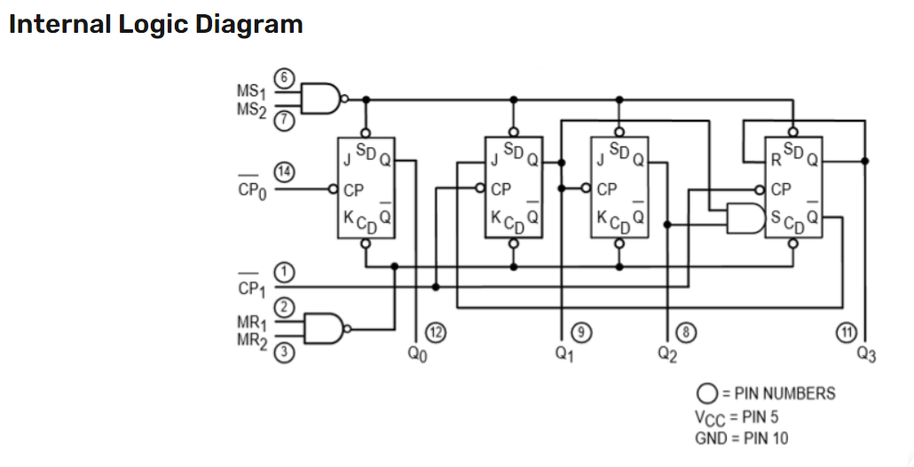

Fig: Pin diagram of 74SL90

Fig: Internal Logic Diagram

* 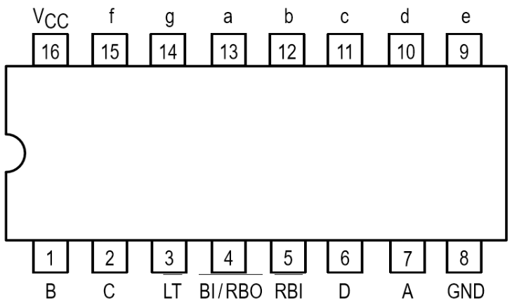74LS47N IC:

**74LS47** is a BCD to 7-segment decoder/driver IC. It accepts a binary coded decimal as input and converts it into a pattern to drive a seven-segment for displaying digits 0 to 9. **74LS47 IC** accepts four lines of BCD (8421) input data and generates their complements internally. The data is decoded with seven AND/OR gates to drive indicator LEDs of the seven segment directly.

Fig: Pin Diagram

* 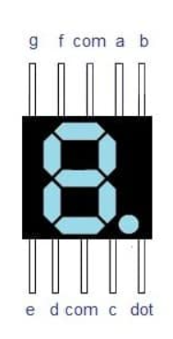7 Segment Display:

A seven-segment LED is a digital display module specialized to display numerical information.  
Light-emitting diodes (LEDs) arranged in the shape of numbers offer an easily visible display.  
They are sometimes called "seven-segment displays" or "seven-segment indicators. In this project we use the common anode configuration of the 7 segment display.

Fig: Pin Diagram

* 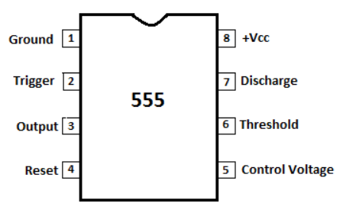555 Timer IC:

The 555 timer IC is an [integrated circuit](https://en.wikipedia.org/wiki/Integrated_circuit) (chip) used in a variety of [timer](https://en.wikipedia.org/wiki/Timer), delay, pulse generation, and [oscillator](https://en.wikipedia.org/wiki/Electronic_oscillator) applications, ie, They provide signals to a digital system to change its state.The 555 timer IC generally operates in 3 modes: Astable Mode, Monostable Mode, Bi-stable modes. In this project, we use the 555 timer to generate pulse in astable mode.

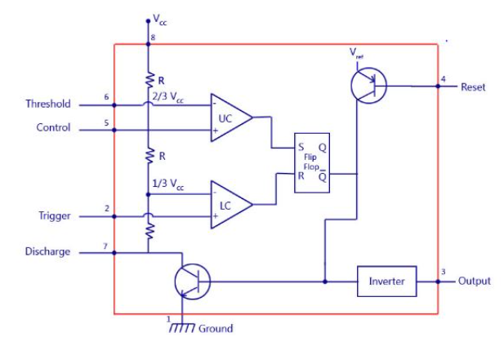 Fig: Pin Diagram

Fig: Internal Circuit of 555 timer.

* Potentiometer

A potentiometer is a three-terminal resistor with a sliding or rotating contact that forms an adjustable voltage divider. If only two terminals are used, one end and the wiper, it acts as a variable resistor or rheostat. In this project, we use the potentiometer as a variable resistor to fluctuate the resistance in the pulse generator circuit to change the timing of the pulses.

* Capacitor

A capacitor is a two-terminal electrical device that can store energy in the form of an electric charge. It consists of two electrical conductors that are separated by a distance. We use a 2200 uF and a 2.2 uF capacitor in our project.

* Ceramic Capacitor

Ceramic capacitors have smaller capacitance values compared to electrolytic or tantalum capacitors.

* Resistors

Resistor is defined as a passive electrical component with two terminals that are used for either limiting or regulating the flow of electric current in electrical circuits. The main purpose of resistor is to reduce the current flow and to lower the voltage in any particular portion of the circuit. Here we use several 1k ohm resistors between 7447 and the 7 segment displays to reduce the voltage going to the displays.

* Jumper Wires
* LEDs
  1. **Procedure:**

To simplify the circuit, let us divide the circuit into 3 parts. The 1st part consists of the pulse generator circuits. The 2nd part is the mod 60 counter that counts every milliseconds. The 3rd part is another mod 60 counter that counts every seconds.

1st part:

We design two pulse generator circuits using two 555 timers. The 555 timers are configured in astable mode. In the first pulse generator circuit we use appropriate resistances and capacitor such that it produces a pulse every 1 milisecond. Similarly, in the second pulse generator circuit we use appropriate resistances and capacitor such that it produces a pulse every 1 second. These pulses then trigger the respective decade counter.

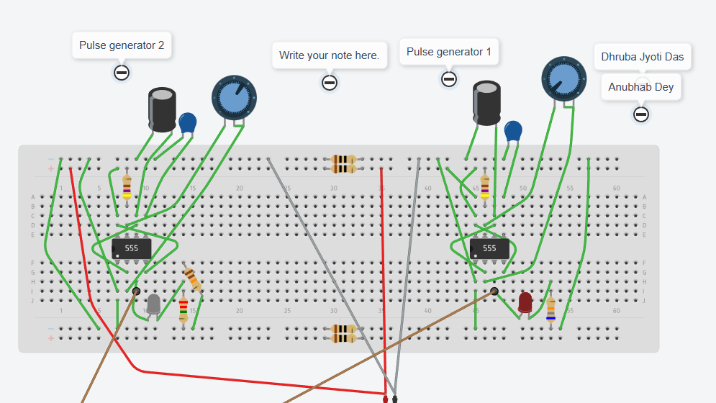

Fig: 2 pulse generators using 555 timer IC (tinkercad simulation)

2nd part:

* The output pin of the first 555 timer, ie, pin 3 is connected to the pin 14 of the 1st 7490 decade counter. The timer creates a pulse that triggers the circuit every 1 millisecond.
* 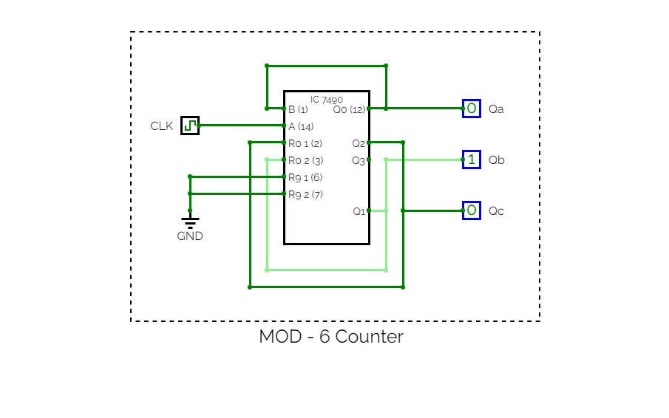We design the first mod-60 counter. It is designed as a cascading mod-10 and mod-6 counter. After deducing the mod 6 and mod 10 counter for 7490, we get the following circuit digrams:

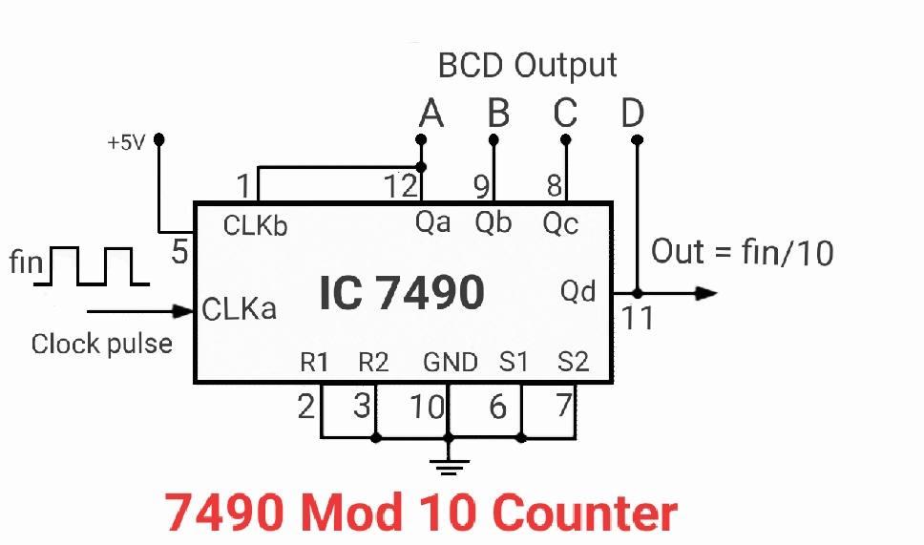

Fig: Mod 6 counter in 7490

Fig: Mod 10 counter in 7490

* 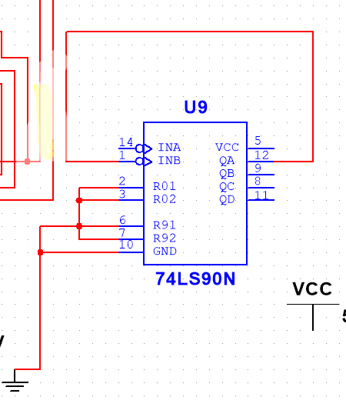In the first 7490, we connect the pin s 2, 3, 6, 7, 10 together with the ground.

Also we connect pin 1 and 12.

* Pin 11 is connected to the input pin D of the first 7447.

Pin 8 is connected to the input pin C.

Pin 9 is connected to the input pin B.

Pin 12 is connected to the input pin A.

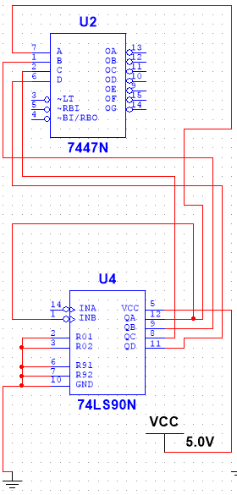

* The output pins a, b, c , d, e, f, g of 7447 is connected to the respective pins a, b, c ,d, e, f, g, of the first 7 segment display.

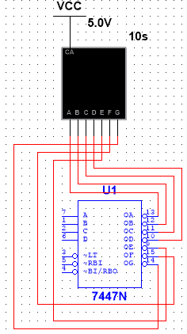

* Pin 11 of the 1st 7490 IC is connected to Pin 14 of the 2nd 7490 IC. Thus both of them are in cascade.
* Similarly we design the second mod-60 counter. It is designed as a cascading mod-10 and mod-6 counter.

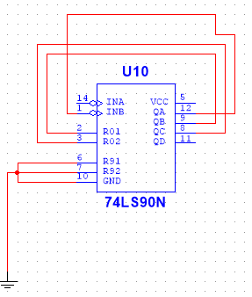

* In the second 7490, we connect the pins 6, 7, 10 to the ground.

Also we connect pin 1 to 12, pin 2 to 9 and pin 3 to 8.

* Pin 11 of the second 7490 is connected to the input pin D of the second 7447.

Pin 8 is connected to the input pin C.

Pin 9 is connected to the input pin B.

Pin 12 is connected to the input pin A.

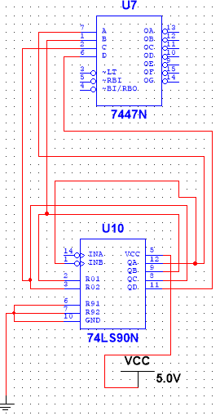

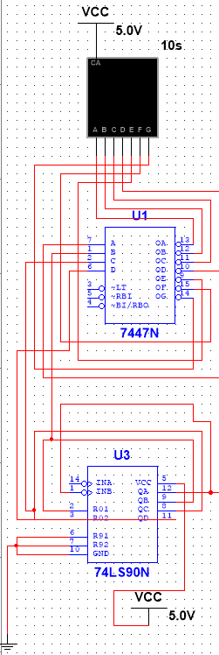

* The output pins a, b, c , d, e, f, g of the second 7447 is connected to the respective pins a, b, c ,d, e, f, g, of the second 7 segment display.
* Pin 11 of the 3rd 7490 IC is connected to Pin 14 of the 4nd 7490 IC. Thus both of them are in cascade.
* Pin 5 of both the 7490 IC is connected to a common power supply.

3rd part.

The output pin of the second 555 timer, ie, pin 3 is connected to the pin 14 of the 3rd 7490 decade counter. The timer creates a pulse that triggers the circuit every 1 second. The design is similar to the 2nd part.

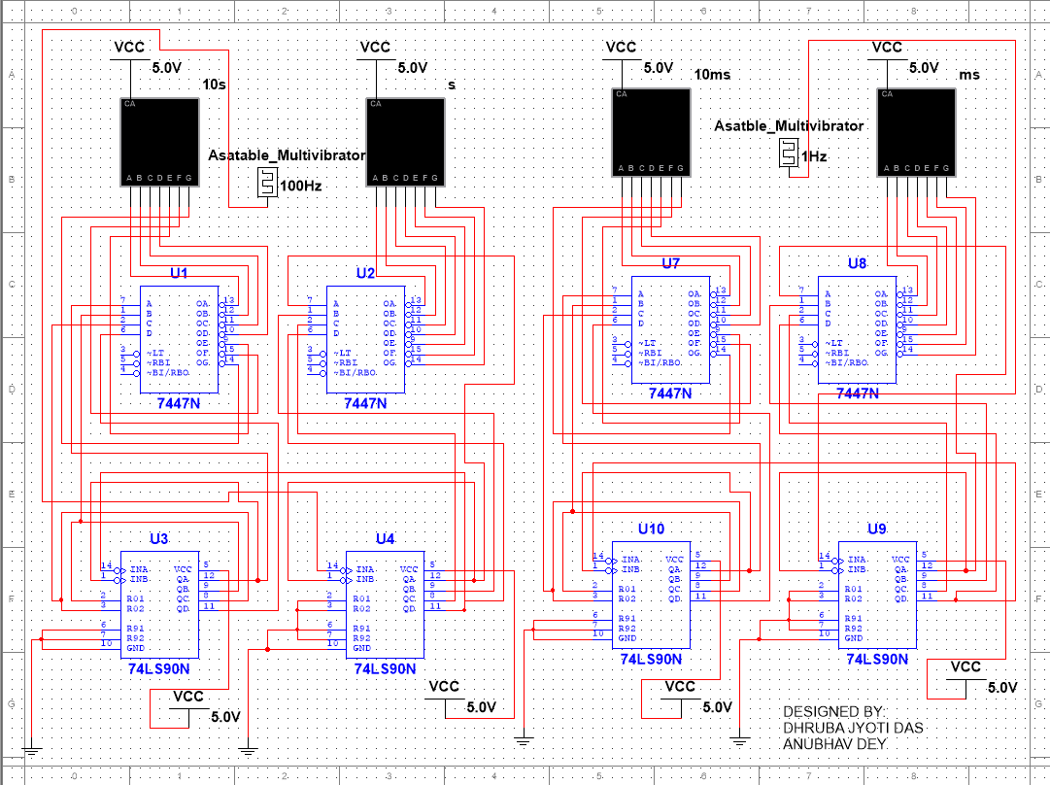

1. **Circuit Diagram**
   1. **Pulse generator circuit**

Fig: Two 555 timers in astable mode. Left is pulse generator 2 (for seconds) and right is pulse generator 1 (for milliseconds)

* 1. **Counter circuit:**

Fig: The full counter circuit

1. 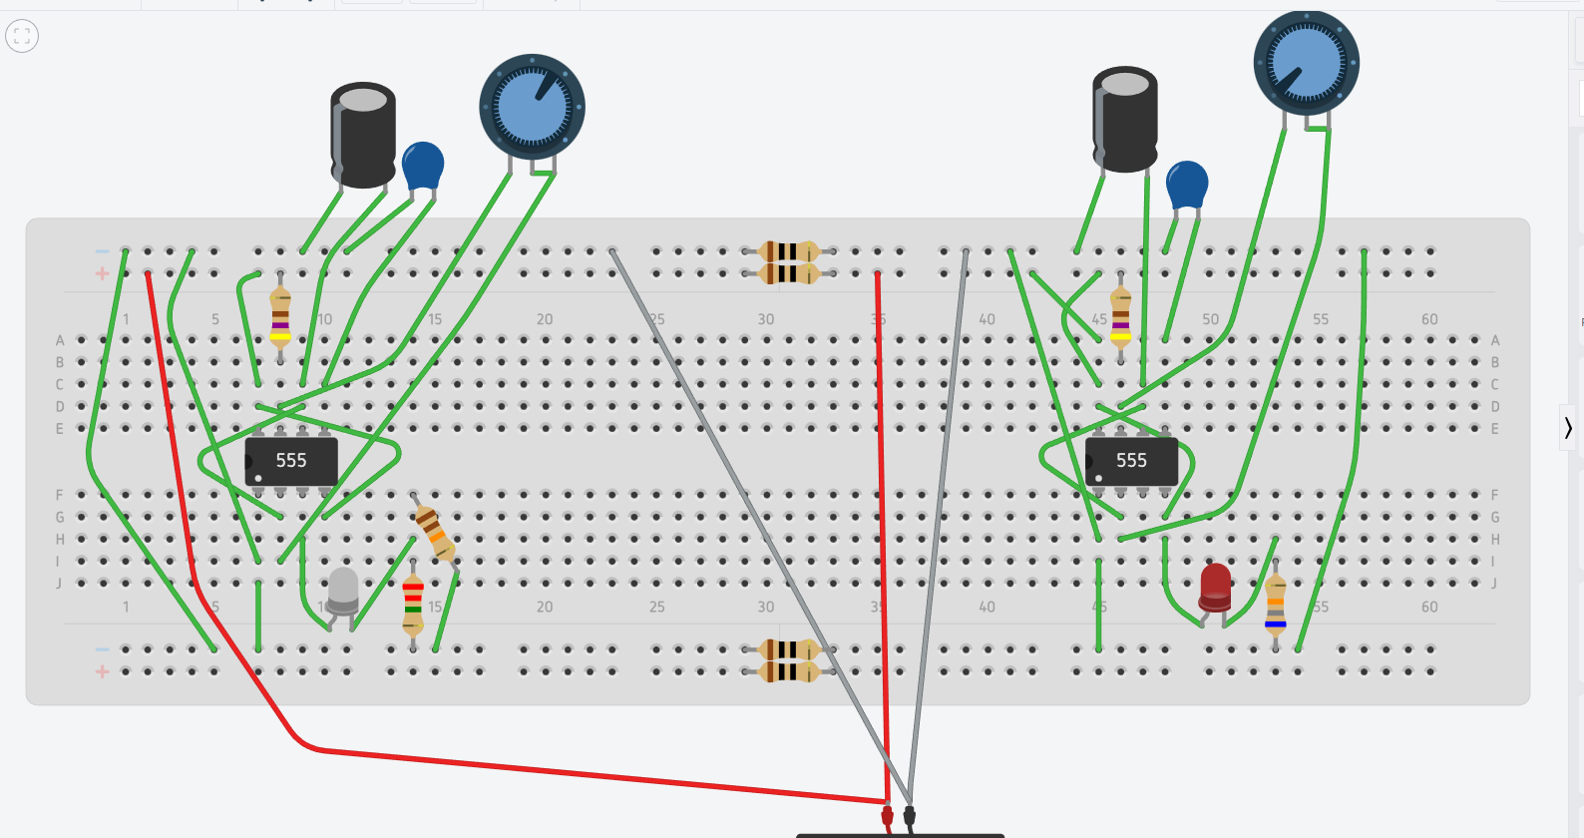**Simulation Results:**

Fig: Pulse Generator simulation in Tinkercad. Glowing LEDs indicate that they are working properly.

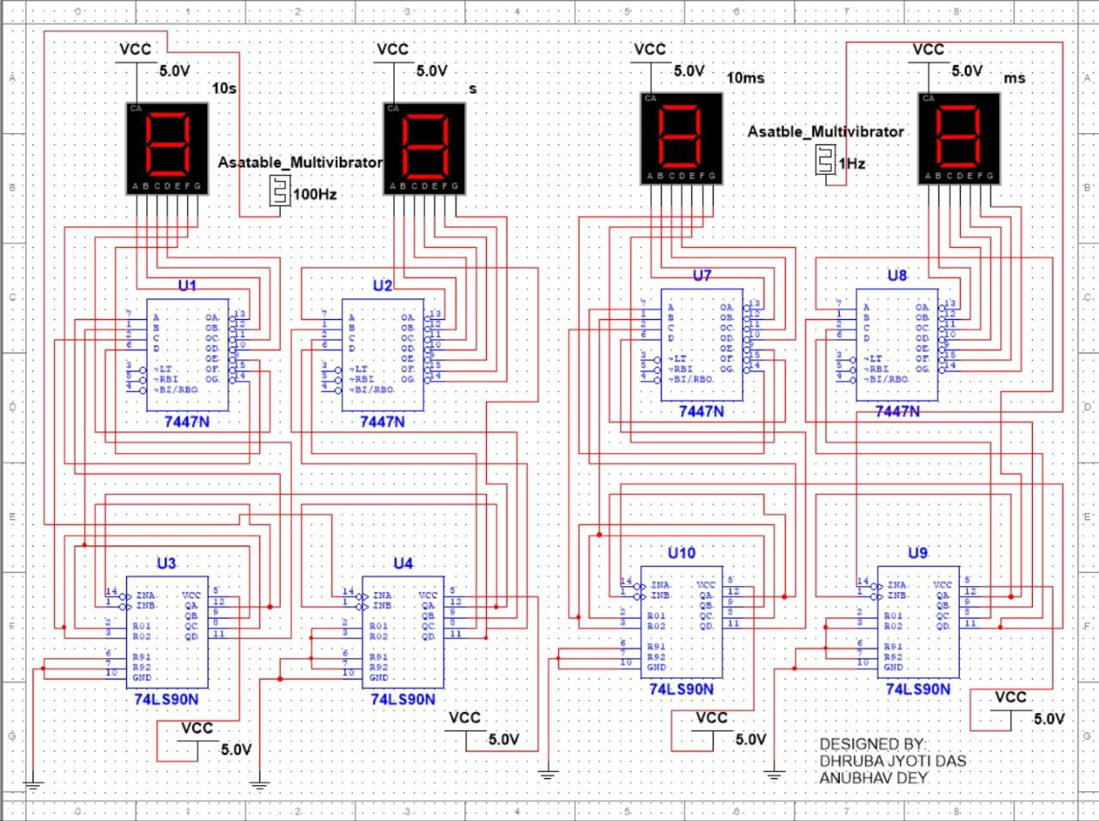

Fig: Full counter circuit simulation in Multisim

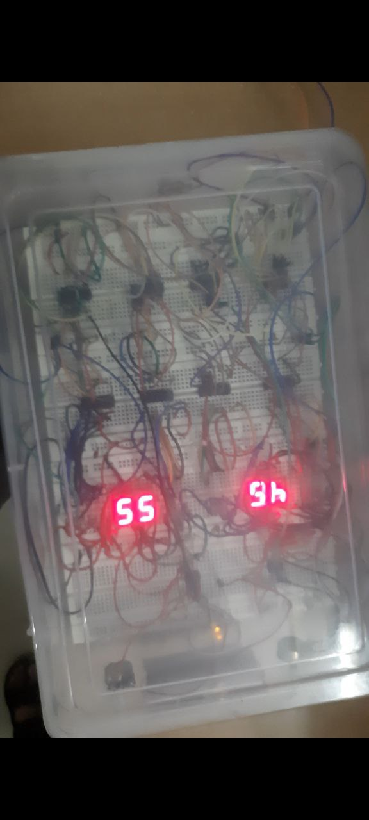**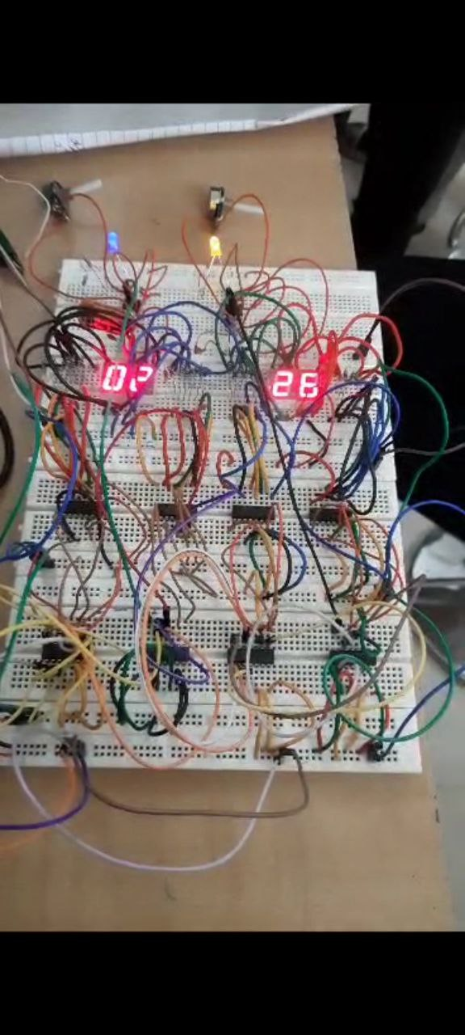5.2. Project Photographs:**

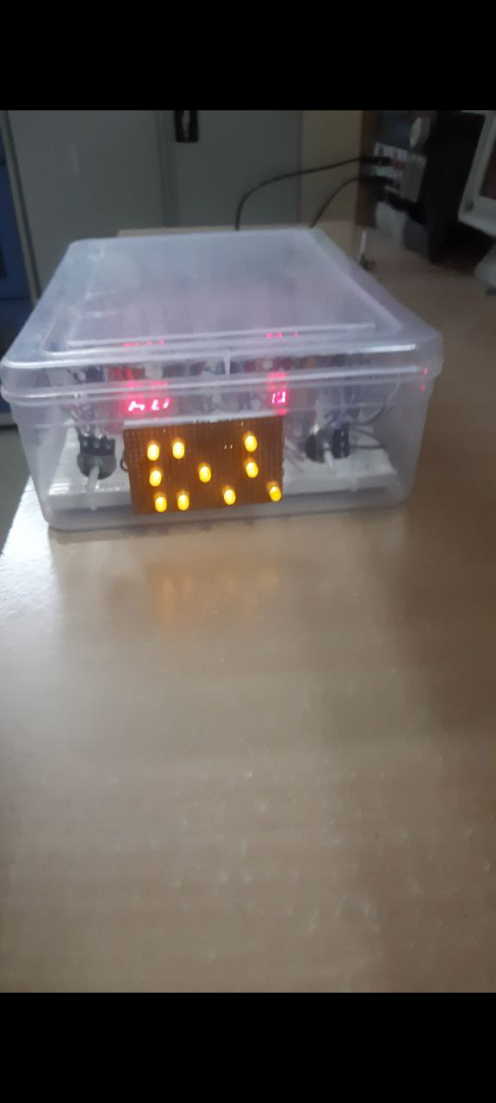

Fig: Side view of the project

Fig: Top view of the project

1. **Observations and Results:**
   1. **Observations:**

When we supply a constant voltage(say 5 volts), firstly we observe that the LEDs connected in the output pin of both the 555 timers, lit up and starts flickering at different rates. We come to know that the pulse generator circuits are working properly.

The two different 555 timers send their pulses and trigger the 1st and the 3rd decade counter. In the first seven segment display, we observe that the count reaches a maximum of value 9 and it triggers the second counter to increment its count by one. This process continues until the count reaches 59. After the count reaches 5 in the second 7 segment display, the count restarts from 00. Since the first pulse generator triggers the counter every 1 millisecond so we observe that in every 1 millisecond the count is incremented by one so it works as a millisecond watch.

Similarly, in the second seven segment display, we observe that the count reaches a maximum of value 9 and it triggers the fourth counter to increment its count by one. This process continues until the count reaches 59. After the count reaches 5 in the fourth 7 segment display, the count restarts from 00. Since the first pulse generator triggers the counter every 1 second so we observe that in every 1 second the count is incremented by one so it works as a millisecond watch.

When the push button, connected to the VCC, is pressed, the count restarts.

* 1. **Results:**

The implementation of the digital stopwatch utilizing 7-segment displays and the 7490 and 7447 ICs has yielded successful outcomes. The system effectively counts seconds and milliseconds, providing accurate time measurements and displaying them on the 7-segment display.

During testing, the stopwatch displayed the correct count for both minutes and seconds, incrementing from 00:00 and reaching up to 59:59. The counting operation was precise and reliable, ensuring accurate timekeeping. The integration of the 7490 decade counter and the 7447 BCD-to-7-segment decoder facilitated the conversion of binary-coded decimal values to the corresponding segments of the 7-segment display, resulting in clear and easily readable time displays.

The pulse generator circuit, incorporating the 555 timer and potentiometer, allowed for manual calibration of the pulse frequency. By adjusting the potentiometer, the pulse frequency could be modified, enabling customization of the time measurement. This feature proved to be valuable in adapting the stopwatch to different timing requirements, such as converting between minutes and seconds.

The independent counting of minutes and seconds provided an advantage in accurately measuring and displaying time. The two mod 60 counters worked seamlessly together, ensuring the correct progression of time without interference or synchronization issues.

* 1. **Limitations:**

While the digital stopwatch project utilizing 7-segment displays, the 7490 decade counter, and the 7447 BCD-to-7-segment decoder offers several advantages, it is important to consider its limitations:

Limited Time Range: The stopwatch is designed to count up to 59 seconds and 59 milliseconds (although it could be calibrated up to 59 minutes). It does not have the capability to measure time beyond this range. This limitation restricts its use in applications that require longer time measurements or timing intervals.

Lack of Precision: The accuracy of the stopwatch is dependent on the pulse generator circuit and the stability of the timing components. Variations in the components or external factors may introduce slight inaccuracies in the time measurements. It may not be suitable for applications that require high precision timing.

Manual Calibration: The pulse generator circuit allows for manual calibration of the pulse frequency by adjusting the potentiometer. While this provides flexibility, it requires manual intervention and may not offer precise or easily reproducible calibration. Automated calibration mechanisms would enhance the accuracy and convenience of the stopwatch.

Power Dependency: The operation of the stopwatch is dependent on a stable power supply. Any power interruptions or fluctuations may disrupt the time measurement or cause the device to reset. Adequate power supply and protection measures are necessary for reliable operation.

1. **Future Aspects:**

The digital stopwatch project opens up several avenues for future development and enhancement. Here are some potential future aspects that can be explored:

* Energy Efficiency: Use of renewable sources like mini solar panel to drive the circuitry could have huge potential.
* Portability and Convenience: The compact and portable nature of the digital stopwatch enhances its usability in various settings. Its lightweight design and user-friendly interface make it a convenient timekeeping solution that can be easily carried and used on the go.
* Design Optimization: The physical design of the stopwatch can be improved for better ergonomICs, durability, and aesthetICs. Compact and sleek designs with rugged enclosures would enhance the portability and longevity of the stopwatch.
* Automated Calibration: Implementing an automated calibration mechanism would enhance the accuracy and convenience of the stopwatch. This could involve integrating a real-time clock (RTC) module or utilizing external time synchronization signals to automatically adjust the timing circuitry.
* Additional Timing Functionalities: Expanding the stopwatch's capabilities by incorporating additional timing functionalities would increase its versatility. This could include features such as lap time recording, split timing, countdown timers, or multiple independent timers. Adding these functionalities would require the integration of more complex circuitry and user interface components
* Integration with Other Systems: Exploring opportunities for integration with other electronic systems or devices could expand the application possibilities of the stopwatch. This could involve connecting the stopwatch to a computer or microcontroller for data logging, synchronization with external events, or integration into larger timing systems.

1. **Conclusion:**

The digital stopwatch project utilizing 7-segment displays, the 7490 decade counter, and the 7447 BCD-to-7-segment decoder has successfully demonstrated the implementation of a functional and reliable timing device. Throughout the project, significant progress has been made in accurately measuring and displaying minutes and seconds.

The stopwatch operates effectively, counting time from 00:00 to 59:59 with precision and clarity. The integration of the 7490 decade counter and the 7447 BCD-to-7-segment decoder ensures accurate conversion of binary-coded decimal values to the corresponding segments of the 7-segment display. This results in clear and easily readable time displays.

The pulse generator circuit, incorporating the adjustable potentiometer, provides the flexibility to manually calibrate the pulse frequency. This feature allows for customization and adaptation of the timing according to specific requirements. The independent counting of minutes and seconds ensures accurate measurement and display of time without interference or synchronization issues.

Although the project has certain limitations, such as the restricted time range and manual calibration, it serves as a solid foundation for future improvements and enhancements. Potential areas for further development include automated calibration mechanisms, additional timing functionalities, and user interface enhancements.

The digital stopwatch project has potential applications in various domains, including sports, laboratories, industrial processes, and educational settings. Its simplicity and effectiveness make it a valuable tool for timekeeping and measurement purposes.

In conclusion, the digital stopwatch project has successfully achieved its objectives by providing an accurate and reliable timing device. The integration of digital circuitry, the 7490 decade counter, and the 7447 BCD-to-7-segment decoder has proven to be a successful approach. The project's outcomes and future prospects showcase its practicality and potential for further advancements, making it a valuable contribution to the field of timing devices and electronic circuit.

1. **References:**
2. Definitions of components.

wikipedia.org

1. 555 Timer, Texas Instruments- SNAS548D –FEBRUARY 2000–REVISED JANUARY 2015. Available at <https://www.ti.com/lit/ds/symlink/lm555.pdf>
2. 7490, Fairchild semiconductors. Available at <https://pdf.datasheetcatalog.com/datasheets/70/375725_DS.pdf>
3. 7447 datasheet. Available at

<https://pdf1.alldatasheet.com/datasheet-pdf/view/82663/ETC/7447.html>

1. LT542 Common Anode.

<https://pijaeducation.com/arduino/seven-segment/seven-segment-led-types-and-pin-config/>

1. About mod counters.

<https://www.electronics-tutorials.ws/counter/mod-counters.html>

Top of Form

Bottom of Form